Practical Task-5
= Open Namecheap.com in one tab and GoDaddy.in in another tab
= Think of a business idea you'd like to start one day (e.g., food delivery in your city, online tuition, handicraft selling, fitness coaching).
= Search for 3 different domain name ideas for your business on both platforms.
= Note down:
(a) Is your first-choice .com available?
(b) Price on Namecheap vs GoDaddy India,
(c) What alternatives (e.g., .in, .co.in, .net) are available and at what price?
= Use ChatGPT Prompt above to generate 10 AI-suggested domain names for your business idea.
= From the AI suggestions, check availability of your top 3 choices on Namecheap.
= Check if your chosen domain name's social media handle is available: search '@yourdomain' on Instagram and
= Submit: A comparison table with 5 domain names, their availability, price, and your final top pick with 3 reasons why you chose it.Namecheap & GoDaddy

ANSWER :-
- Opened Namecheap.com and GoDaddy.in.
- Business I though about is fashion designing.
- (a)radiantrp
(b) glowpr
(c)crispbeads

- (a)Yes, my first choice .com is available.
(b) Namecheap.com = ₹63,207.08
GoDaddy.in = ₹66,190.47
(c) Namecheap.com = .net = ₹1,135.00
GoDaddy.in = .in,.co.in =₹99.00 and .net= ₹1
5. 10 Domain names for my websites,
1.ByRaheen.com
2.RaheenStyle.com
3.RaheenCollective.com
4.RaheenHouse.com
5.RaheenMuse.com
6.RaheenLabel.com
7.RaheenDesigns.com
8.MaisonRaheen.com
9.AtelierRaheen.com
10.RaheenVerse.com

6 (a) ByRaheen.com
- It is available on both platforms GoDaddy and Namecheap.
(b) RaheenStyle.com
- It is available on both platforms GoDaddy and Namecheap.
(c) RaheenCollective.com
- It is available on both platforms GoDaddy and Namecheap.
7. (a) ByRaheen.com already exists on Instagram
(b) RaheenStyle.com is not on Instagram so I can have it
(c) RaheenCollective.com is not on Instagram so I can have it too while none of the domains among above exists on LinkedIn so if I want I can have option 2 and 3 for my Instagram and LinkedIn profile.
Domains name | Availability  (Namecheap) | Availability  (GoDaddy) | Price  (Namecheap) | Price  (GoDaddy)
1.ByRaheen.com | Available | Available | ₹1,025.86/yr | ₹1
2.RaheenStyle.com | Available | Available | ₹1,025.86/yr | ₹1
3.RaheenCollective.com | Available | Available | ₹1,025.86/yr | ₹1
4.RaheenHouse.com | Available | Available | ₹1,025.86/yr | ₹1
5.RaheenVerse.com | Available | Available | ₹1,025.86/yr | ₹1
This is Q-8 answer table and ,

These are my three reasons why my top pick is ByRaheen.com,
1.It sounds like a designer label as my brand is related to fashion by goes well with it.
2.It is short and simple for users to remember it.
3.If in future with clothing suppose I want to start business for accessories and other beauty products this name would perfectly go with it.

PRACTICAL TASK: L6 — Create InfinityFree Account and Install WordPress
- Go to infinityfree.com and click 'Create Free Account'. Register with your email.
- After logging in, click 'Create Account' → choose a free subdomain (e.g., yourbrand.epizy.com).
- Once account is created, go to your Control Panel (it looks like cPanel).
- Find 'Softaculous Apps Installer' and click on WordPress.
- Install WordPress: Leave directory blank, set site name as '[Your Name] Digital Marketing Practice Site', create a unique admin username (NOT 'admin'), set a strong password.
- After installation, log in to yourdomain.epizy.com/wp-admin and take a screenshot of your WordPress dashboard.
- Navigate to: Appearance > Themes > Add New > Search 'Astra' > Install and Activate.
- Go to Settings > General and change your Site Title and add a tagline.
- BONUS: If you have budget (Rs. 99/month), sign up for Hostinger India instead and get a free domain!
- Submit: Screenshot of WordPress dashboard + homepage of your new site.

ANSWER:-

10- 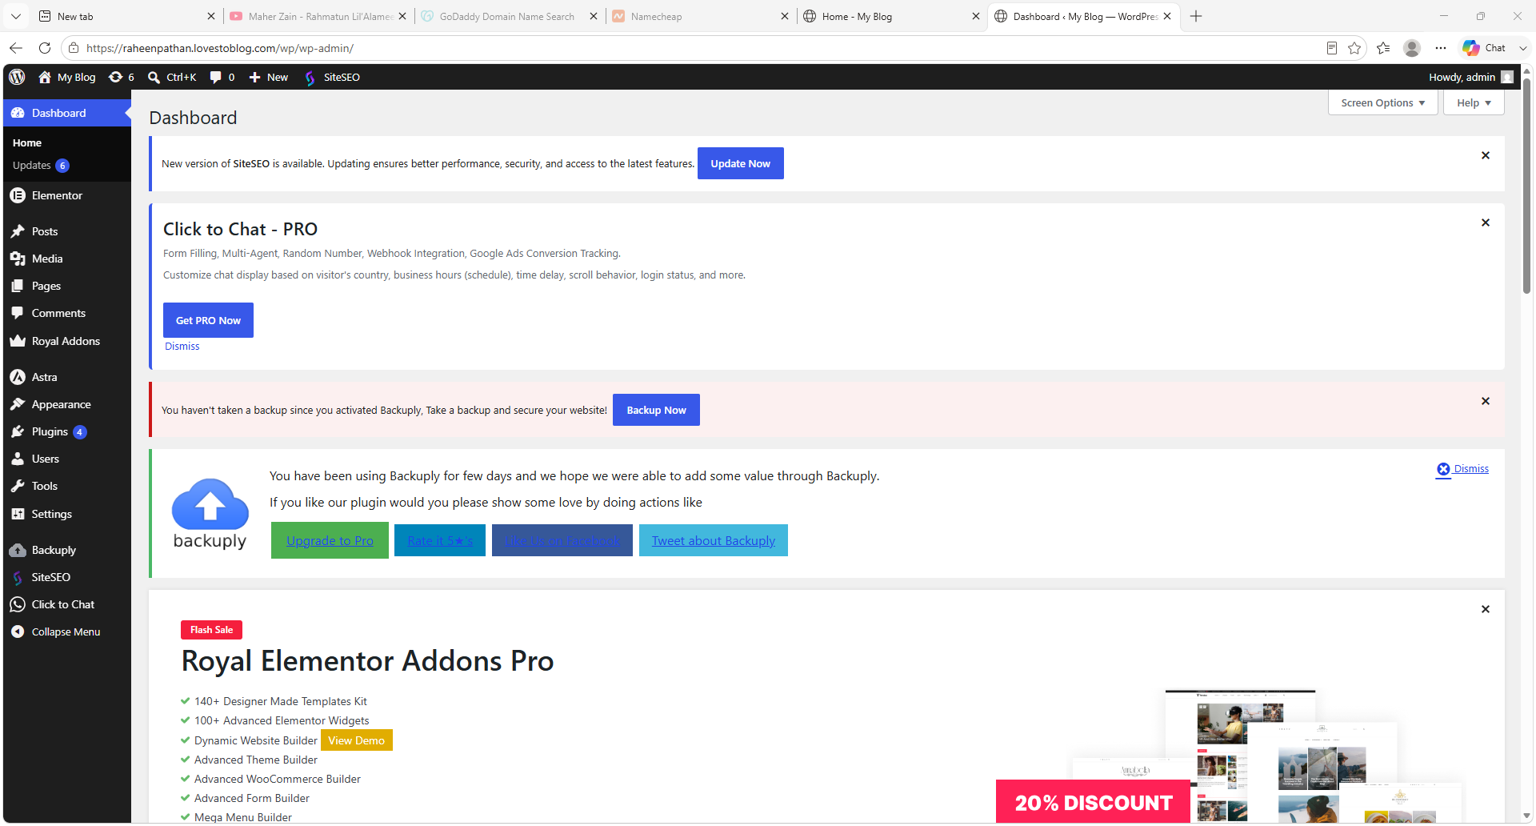

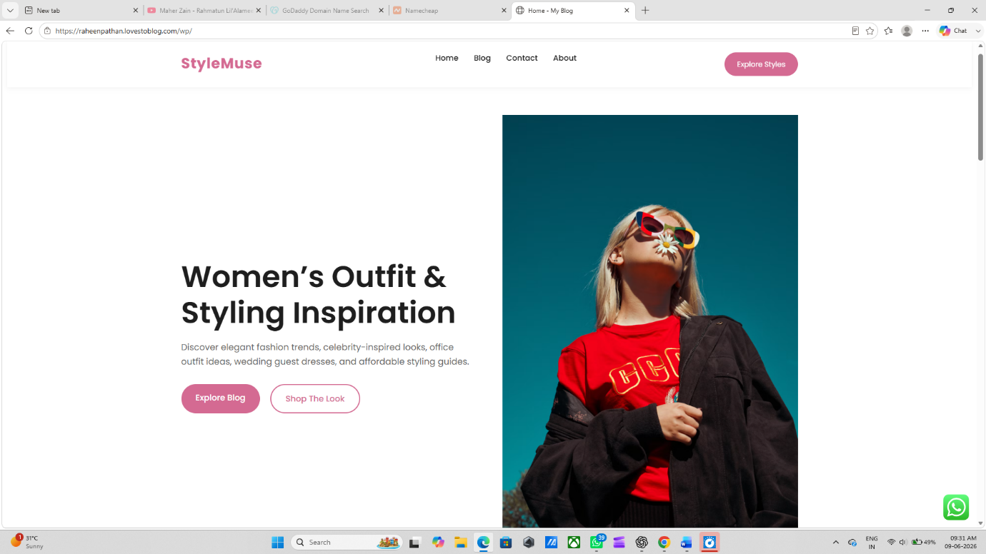

PRACTICAL TASK: L7 — Create 'About Us' Page and a Blog Post
- Log in to your WordPress site (from L6 practical).
- CREATE AN ABOUT US PAGE: Go to Pages > Add New. Title: 'About Us'. Write 150 words about yourself and why you're learning digital marketing. Add a professional-looking header image (use Canva.com to create a free banner). Set Featured Image. Click 'Publish'. Add this page to your Navigation Menu.
- CREATE YOUR FIRST BLOG POST: Go to Posts > Add New. Write a post titled: 'Why Every Indian Business Needs SEO in 2025'. Minimum 300 words (use your L2 case study knowledge). Assign Category: 'SEO Tips'. Add 3-4 relevant Tags. Set a Featured Image (use an India-relevant image from Unsplash.com — free). Click 'Publish'.
- ORGANIZE CONTENT: Go to Posts > Categories. Create 3 categories: 'SEO Tips', 'WordPress Tutorials', 'Digital Marketing'. Assign your blog post to 'SEO Tips'.
- CREATE A MENU: Go to Appearance > Menus. Create 'Main Navigation' with: Home, About Us, Blog, Contact. Save and check your live website.
- ADD A USER: Go to Users > Add New. Add a fake team member with email: teammember@yourdomain.com. Role: Editor. Observe what a new user can do vs Administrator.
- Submit: Screenshots of
(a) your About Us page live,
(b) your blog post live,
(c) your navigation menu,
(d) the Users list showing roles

ANSWER:-

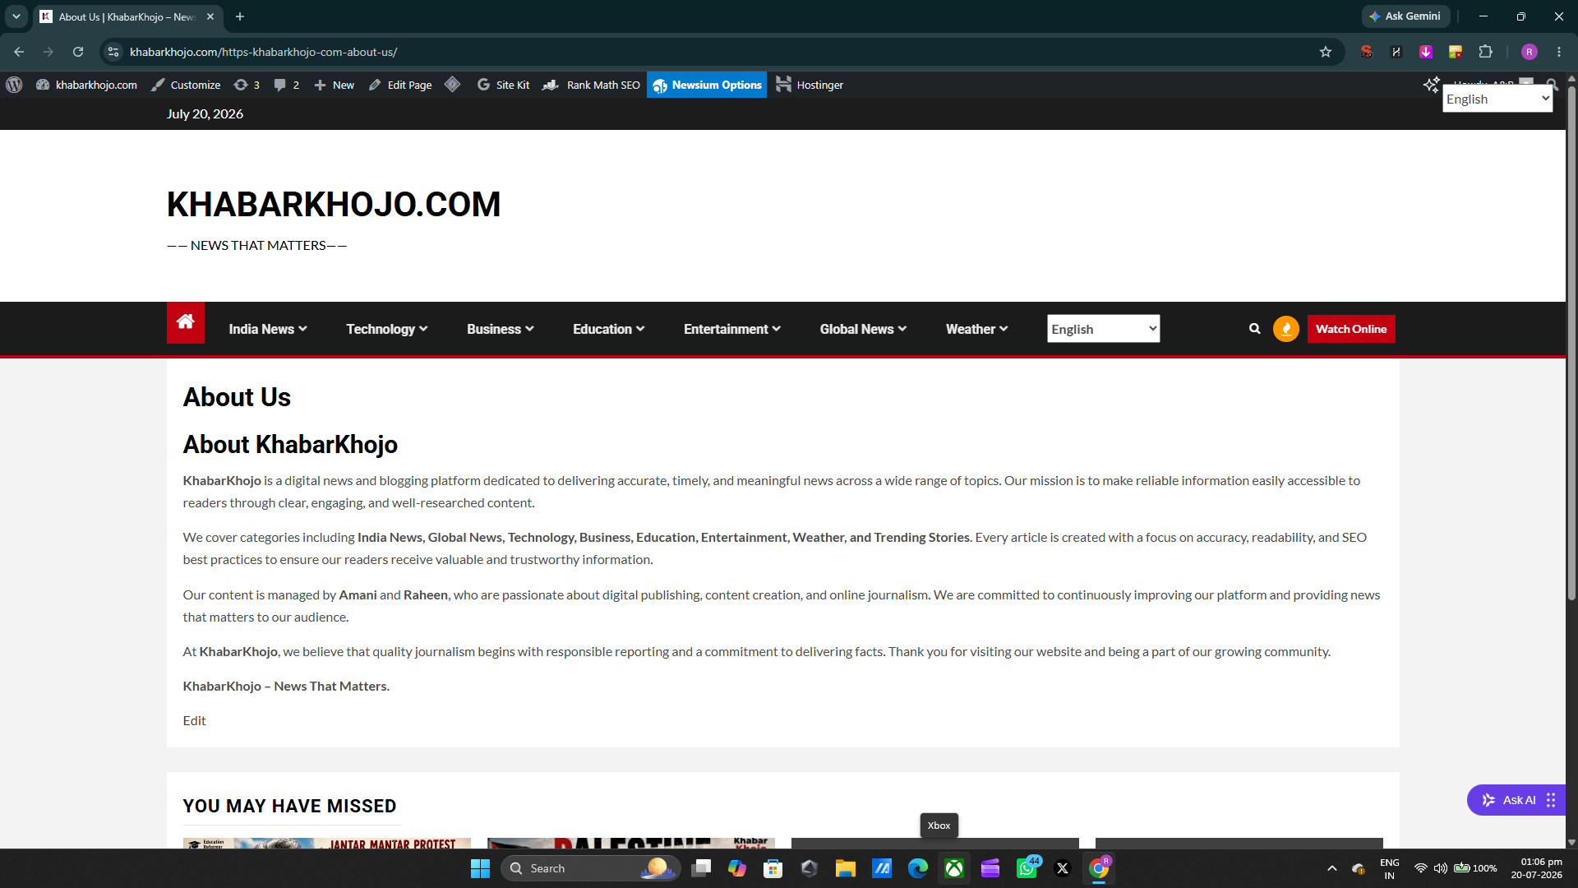This is about us. And

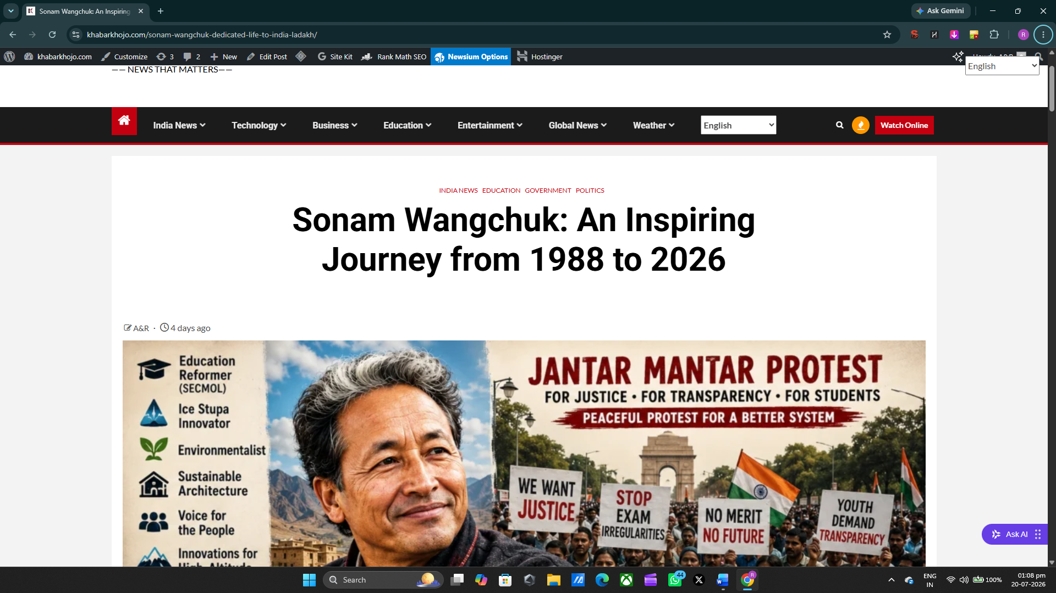
This is Navigational and live blog.

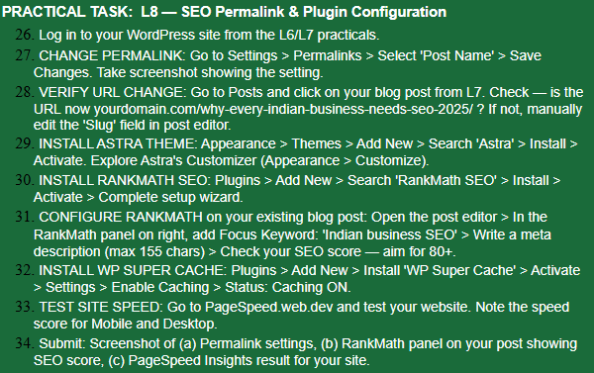

ANSWER: -
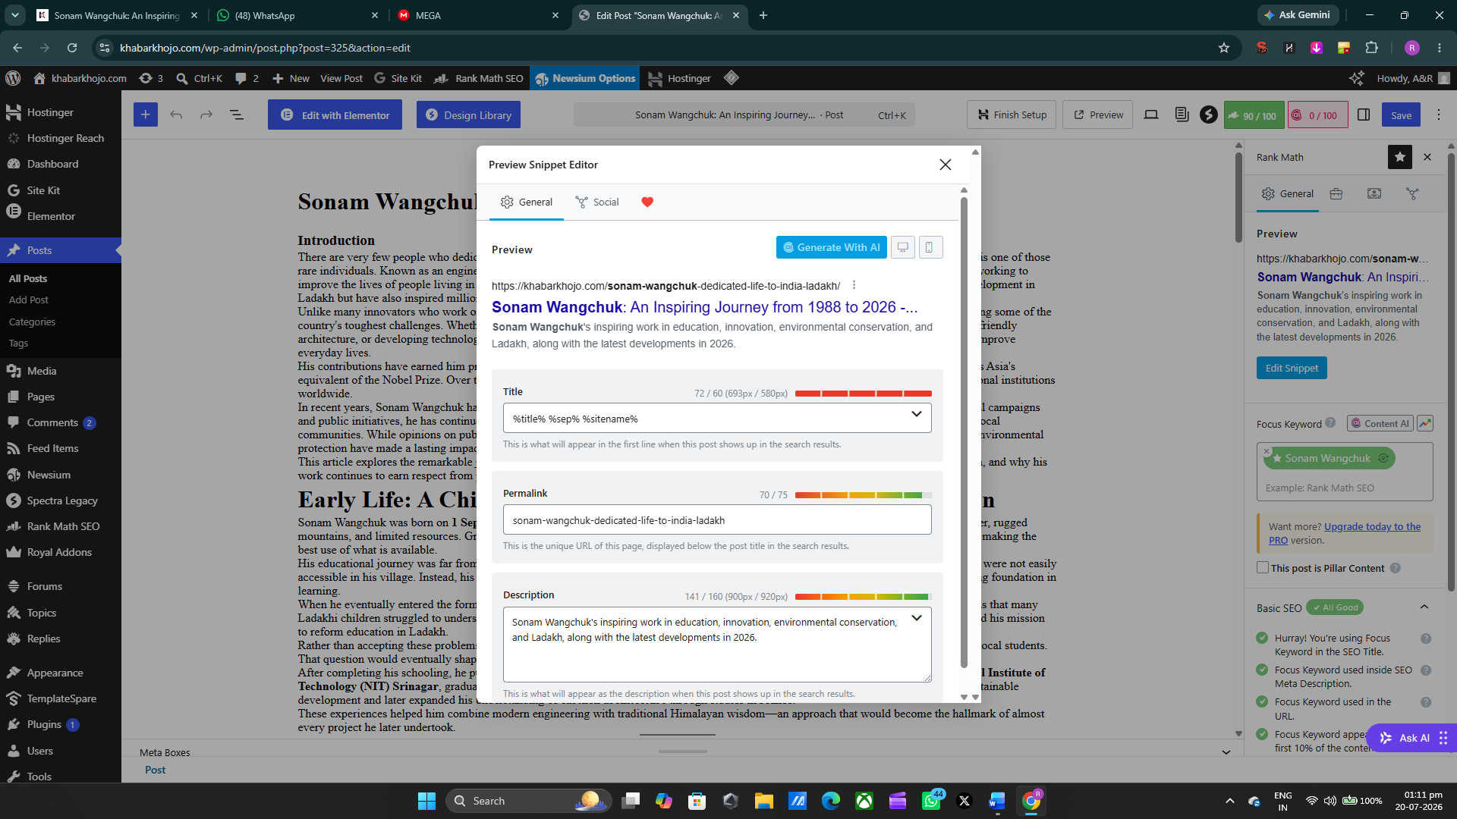
This includes Permalink and score both which is 90.

And this is pagespeed insight.
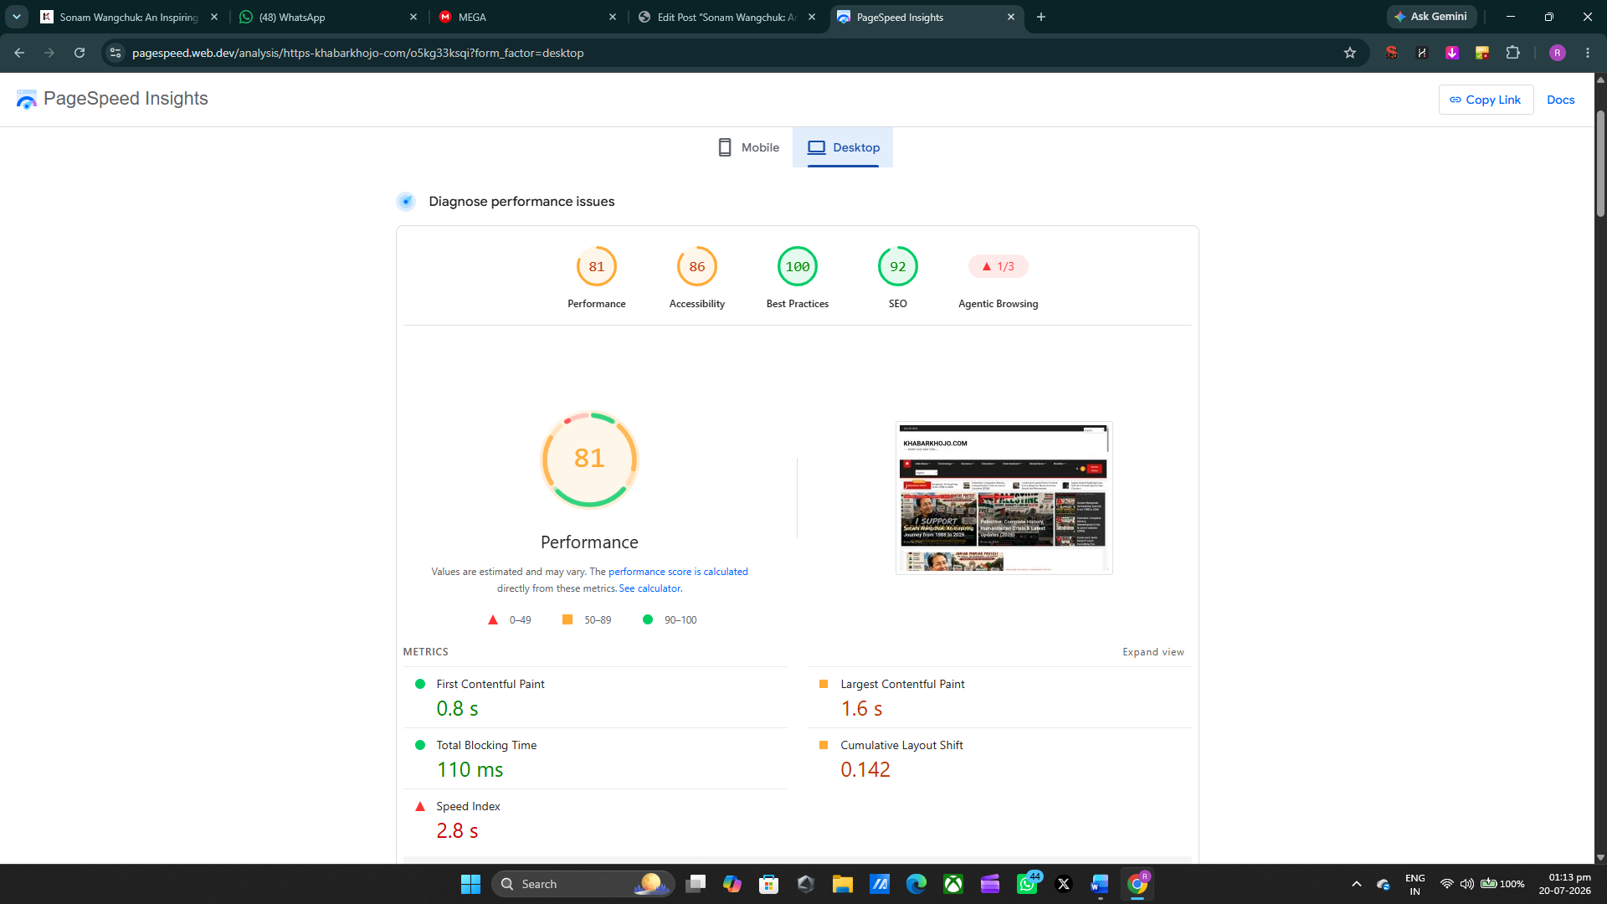

Ab 999hjjhj. (9((Na

